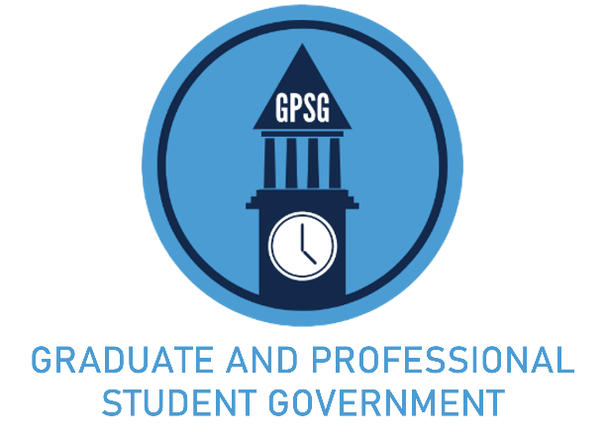
53RD SESSION OF THE GRADUATE AND PROFESSIONAL STUDENT SENATE
2022-2023

GENERAL BILL 53-012

AN ACT TO IMPROVE THE GPSG TRAVEL AWARDS PROCESS
Short Title: Travel Awards Improvement Act
Sponsor(s): Theodore Nollert, President; Nicholas Moloci, Senator for Health Policy &
Management; Joshua Bakita, Senator for Computer Science
Signatories(s): Elena Vidrascu, Senior Vice President
Date: August 23rd, 2022
Referred to: GPSG Rules & Judiciary Committee on September 30th, 2022
Committee Action: Recommended Favorably by Vote of 4-0-0 on Oct 1st 2022
Senate Action: [Passed/Failed] by Vote of [Yes Votes-No Votes] on [Date of Senate Vote]
President Action: [Signed/Vetoed] on [Date of Action]

WHEREAS, Title VIII of the GPSG Code empowers the Senate to provide Travel Awards to current students via a competitive application process; and

WHEREAS, The GPSG Code includes policies for Travel Awards that are ambiguous to or onerous on applicants; and

WHEREAS, The cost of travel and conference registration has risen substantially since the last issue of the Code, with annual airfare inflation in excess of 33% as of the August 2022 reading by the US Bureau of Labor Statistics; and

WHEREAS, Prohibiting the combination of GPSG Travel Awards with other funds discourages students from seeking supplemental funding; and

WHEREAS, GPSG Travel Award funds are for use once reimbursement sources from advisors, grants, or departments are exhausted; and

WHEREAS, An earlier version of this Act was recommended favorably by Legislative Summer Governance by vote of 4-0 on August 23rd, 2022; now, therefore be it

ENACTED BY THE GRADUATE AND PROFESSIONAL STUDENT SENATE:

SECTION 1: Revisions to Travel Award Processes
The following changes shall be enacted to the GPSG Code to clarify the responsibilities of the Travel Awards committee, to clarify summer travel requirements, to efficiently allow for the combination of awards, and to adjust for inflation.

Title VIII § 4.001 Submission to the Senate
- The STAC shall recommend awards decisions to the Senate no later than 35 days following at the meeting immediately following the conclusion of an application deadline.

Title VIII § 1.001 Qualifications for Travel Award Candidates
- Enrolled for the semester in which the travel is to occur. in the Spring semester for travel from January through June, or the Fall semester for travel from July through December.
Title VIII § 1.002 Eligibility for Travel Awards Candidates
- An applicant is not able to combine TAs.
  - The applicant must certify that they will not use a GPSG TA in conjunction with another funding source for the same trip, unless they have been granted a top-up differential as permitted by § 1.202 of this Title.
  - If the applicant later becomes eligible for other travel funding for the same trip, they must decline either the GPSG TA or the other funding award.
- An applicant may combine TAs with other funds, but all other funds must be declared and GPSG funds may only be used once all other funds are exhausted. Non-declaration of funds is an honor code violation.
Title VIII § 1.101 Conference Travel
- The maximum individual award for domestic travel is $400.00 $800.00.
Title VIII § 1.102 Research Travel
- The maximum individual award for domestic travel is $400.00 $800.00.
Title VIII.1.202 Top-Up Differentials shall be struck.

SECTION 2: Enactment Date
This Act shall be in effect beginning with the October 2022 travel cycle.

Elena Vidrascu Theodore Nollert
Vice President President

